- Create the EMPL table with the following structure:
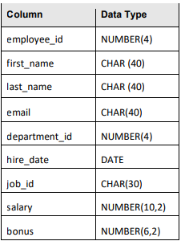
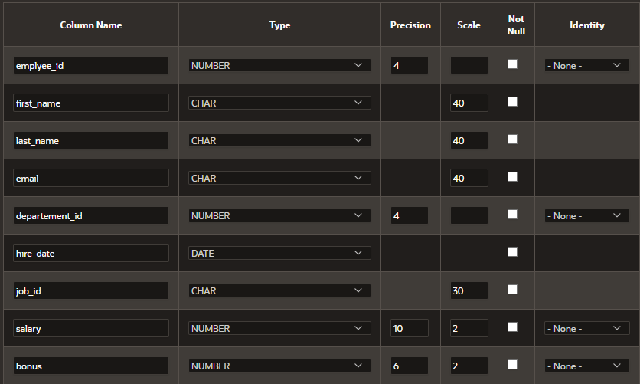

- Insert rows into the tables created based on the following tables:
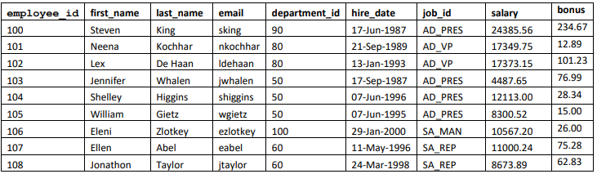
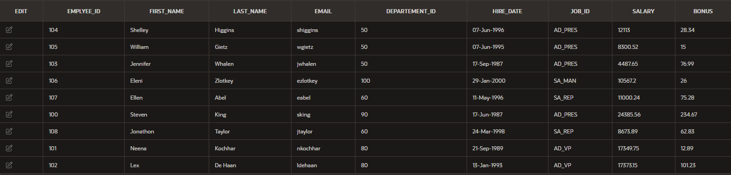

- For all the following questions use the table EMPL (Table1):
- Display all the information about the employees.
Select *
from Table1

- Display the last_name and the first_name for employees having job_id=sa_rep
Select last_name, first_name
from Table1
where job_id='SA_REP'

- Display the last_name and the first_name in uppercase in a new column “Name” for employees having job_id=ad_vp.
Select upper(last_name) ||' '|| upper(first_name )as "NAME"
from Table1
where job_id='AD_VP'

- Increase the salary of employees by 5% and display the last_name, the first_name the salary, and the new salary.
Select last_name, first_name, salary, salary+salary*0.05 as "new salary"
from Table1

- Increase the salary of employees by bonus and display all the information.
Select EMPLYEE_ID, FIRST_NAME, LAST_NAME, EMAIL, DEPARTEMENT_ID, HIRE_DATE, JOB_ID, SALARY, salary+bonus, BONUS
from Table1

6. Decrease the salary of employees by 7% and display the last_name, the first_name
the salary, and the new salary. Use an alias(new_salary) to display the new salary.
Select last_name, first_name, salary, salary-salary*0.07 as "new salary"
from Table1

- Display all the information about the employees having job_id “AD_PRES” and the salary<15000.
Select *
from Table1
where salary<15000 and job_id='AD_PRES'

- Display all the information for employees having job_id=AD_PRES and arrange in descending order according to salary.
Select *
from Table1
where job_id='AD_PRES'
order by salary DESC

- Display the first_name and the last_name in uppercase in a new column „New”, and the department_id for employees having department_id=50 or 80(two methods).
Select last_name ||' '|| first_name as "NAME", DEPARTEMENT_ID
from Table1
where DEPARTEMENT_ID=50 or DEPARTEMENT_ID=80

Select last_name ||' '|| first_name as "NAME", DEPARTEMENT_ID
from Table1
where DEPARTEMENT_ID in (50,80)

10.Display the last names of all employees who have “o” or “a” in their last names.
Select last_name
from Table1
where last_name like '%o%' or last_name like '%a%'

11.Display all employees whose last names start with “K” or „Z”. Arrange in order according to salary.
Select *
from Table1
where last_name like 'K%' or last_name like 'Z%'
order by salary

12.Display all the information about the employees hired after 1st January 1994.
Select *
from Table1
where hire_date>'1-Jan-1994'

13.Display the first_name, the last_name, the dept_id and the salary for employees having bonus. Arrange in order according to salary.
Select first_name, last_name, DEPARTEMENT_ID, salary
from Table1
where bonus!=0
order by salary

14.Increase the salary of employees having job_id “AD_PRES” or AD_VP by 5% and display first_name, last_name, salary and the new salary using an alias.
Select first_name, last_name, salary, salary+salary*0.05 as "new salary"
from Table1
where job_id='AD_PRES' or job_id='AD_VP'

15.Decrease the salary of employees by 5% and display first_name, last_name, salary and the new salary for employees having department_id=50 or 60.
Select first_name, last_name, salary, salary-salary*0.05 as "new salary"
from Table1
where DEPARTEMENT_ID in (50, 60)

16.Display all the information about the employees having salary between 10000 and 15000.
Select *
from Table1
where salary between 10000 and 15000

17.Display the email in uppercase and the job_id with small lettres in a new column „New”.
Select upper(email), lower(job_id) as "New"
from Table1

18.Arrange in order according to salary and display first_name, last_name, salary.
Select first_name, last_name, salary
from Table1
order by salary

19.Display the first character of the first name concatenated to the last_name and the
job_id for employees hired after 1st January 1998

20.Increase the bonus for employees hired after 01.01.95 by 10%.
Select bonus+bonus*0.10
from Table1
where hire_date>'1-Jan-1995'

